LED Strobe Laser Light
User Manual

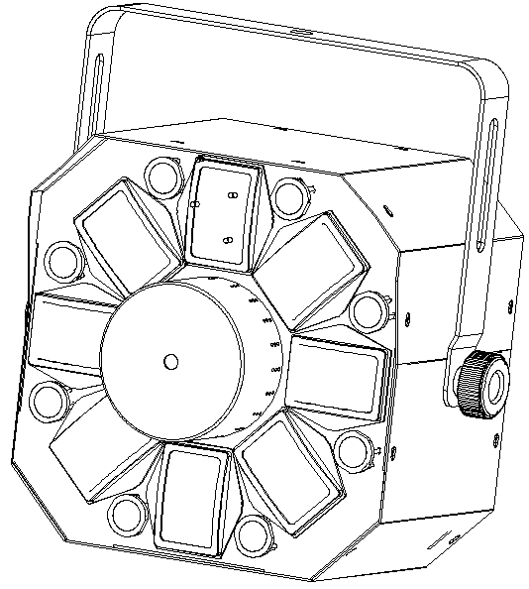

Please read this manual carefully before use!

Contents

Introduction----------------------------------------------------------------------------P2

Silkscreen on light ----------------------------------------------------------------P3

Safety instruction and product specification-------------------------------P4

Menu operation, function ---------------------------------------------------------P5

Channel instruction and controller connection----------------------------P6

Address setting--------------------------------------------------------------------- P7

Structure and material------------------------------------------------------------P8/P9

Installation and Size--------------------------------------------------------------- P10

Wiring diagram---------------------------------------------------------------------- P11

Maintenance, warning and warranty card------------------------------- P12

Introduction
Thank you for purchasing this product. To optimize the performance of this product,prior to use,please read these operating instructions carefully to familiarise yourself with the basic operation of this unit.Please keep the manual in safe price for future reference.

This unit has been tested at our factory before being shipped to you, there is no assembly required.

Once after received this product , please take and put carefully. And check cautiously that whether the product was damaged or not during the transportation.

Checking Parts
Please check if the following parts are included:
1 x LED Laser Light
1 x Power cable
1 x User manual

Caution
Before out factory, this device has passed strict inspection, functions stable and perfect packing. If this device will be operated in any way different to the one described in this manual, the product may suffer damages and the guarantee becomes void. Furthermore, any other operation may lead to dangers like short circuit, burns, electric shock, crash etc. If any technology changes of this manual, company do not notice in further and have interpretation.



CAUTION!

Keep this device away from rain and moisture!

Unplug mains lead before opening the housing!

Warning!


Damages caused by the disregard of this user manual are not subject to warranty. The dealer will not accept liability for any resulting defects or problems.

Silkscreen on light

-------------------------------------------------------------------------------CE compliant
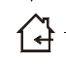
-----------------------------------------------------------------------------Only indoor use

--------------------------------------------------------------------------RoHS Certificate
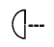
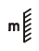
---------------------------The minimum distance from lighted objects(meter)
----------------------------------------------------------------Max. Ambient Temp
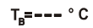
-------------------------------------------------------Max. Housing Temp

-------------------------------------------------------------------------- Safety caution

-------------------------------------------------------------------------Careful burns

-----------------------------------------------------------------Careful electric shock
---- Not suitable for directly installed on the surface of ordinary combustible materials

一.Safety Instructions

- Please open and check whether break or not for transport once receive this fixture, if yes, not use it and contact dealer or manufacture as soon as possible.
- The Max applicable temperature for the light is 40°C. Do not use the light under or above the temperature. ta=40℃
- The fixture is applicable for many occasions, it should keep clean, and avoid long use in overheating or dusty environment. To prevent the fixture from the chemical liquid .
- User must be careful of fire, heat, electric and fall-off that make heavy or fatal injury. Please read this user manual carefully before power on and installation, following safety and operation instruction in it. If still have any questions, please contact dealer or manufacture.
- User must following this user manual, do not open fixture by yourself, if any problems, please contact professional technician, maintenance should by technician.
Do not power on or start the fixture before installation, please stop after working more than 8 hours, which will longer use life.
- Fixed installation, do not by strong shocks.
- The minimum distance between light and the illuminated surface must be more than 1 meter. 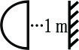

- Never look directly into the light source to avoid hurt to eyes (especially epileptics)!
- When dustproof glass at light output breaks, cracks or other visible damage, user should replace with new glass to continue to use.

二. Installation

- When install this equipment please make sure there's no flammable surfaces (decorated things, etc) and minimum distance of 0.5M from the equipment to the flammable.

- The installation of the effect has to be built and constructed in a way that it can hold 10 times the weight and without any harming deformation.
- The installation must always be secured with a secondary safety attachment, e.g. an appropriate safety rope.Never stand directly below the device when mounting, removing or servicing the fixture.

三、Technical Specifications
- Power supply: AC100V~240V 50/60Hz
- Amp:：BGDP ￠5x20mm 250VAC T2A
- Rated power: 50W
- Laser: R:150m/650nm,G:50mw/532nm
- LED：6pcs 5W RGBWAP；8pcs 3W White LED
- LED effect:Derby
- Laser effect:8 grating effect
- Control mode: Sound Active/ Auto-play/DMX512/Master-Slave
- Channel：10
- Scan system：Step motor
- Operating temperature:10℃~40℃
- Inner Packing(mm):340*270*340
- Outer Packing(mm):700*560*370 (4pcs)
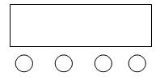
四、LED Digital Display
E
A．（MENU）
B．（UP）
C．（DOWN）
D．（ENTER）
E．LED Display
A B C D

Operating Instruction:
press button marked as “A” to select a function, For details, please see the “OPERATION MENU” section. Press button marked as “B” or button marked as “C” to modify values . Press button marked as “D” to save your settings.

LED Digital Display Operation Menu:
No. | Menu | Function
1 | Addr | DMX address DOWN/UP to +/- (1-512)
2 | AUTO | Aut1,Auto Play1,six colors led derby effect auto play
2 | AUTO | Aut2,Auto Play2，white led auto play
2 | AUTO | Aut3,Auto Play3，laser auto play
2 | AUTO | Aut4,Auto Play4，all effects auto play
2 | AUTO | SPEE,auto speed 0-99
3 | Soun | Sou1,Sound Active 1
3 | Soun | Sou2,Sound Active 2
3 | Soun | Sou3,Sound Active 3
3 | Soun | SESE,sound sensitivity 0-99
4 | Vers | Ve1.0

- When starting up,it will display the last time’s operation .In case without any buttons,it will close screen automatically after 20seconds.When no dmx,the first dot of led display will keep on.When has dmx,the first dot will blink
2. The master light can choose any mode of Auto/Soun modes, the slave light is set as A001, Just one light could be settled to be master.
3.At most 10 lights could be linked in one electricity source.

五、Function：
- Press MENU to select Addr / Chnd/NAnu/ SHOU /CoLo/SPEE/ Auto/Soun / Version , Press ENTER to the next menu or save, Press UP / DOWN to select function, Press ENTER to save; Long Press MENU to exit.
- Addr, Address setting，DOWN/UP to select 1-512
- Chnd, Channel setting
- NAnu, LED brightness adjust and laser(on or off)
- ShoU, select scene and show
- CoLo，select color
- SPEE，Auto speed
- Auto，Auto mode
- Soun，Sound mode
- Vers，version

六、Channel
 |  | DMX-512Value 0-255 | Details
CH1 | Control Mode | 0-9 | Black- out
 |  | 10-39 | Auto Play1(Six colors LED auto）
 |  | 40-69 | Auto Play2（White LED auto）
 |  | 70-99 | Auto Play3（Laser auto）
 |  | 100-129 | Auto Play4（Mixing auto）
 |  | 130-159 | Sound Control 1(Six colors LED sound）
 |  | 160-189 | Sound Control2（White LED sound）
 |  | 190-219 | Sound Control3（Laser sound）
 |  | 220-249 | Sound Control4（Mixing sound）
 |  | 250-255 | DMX Mode
CH2 | RGBWYV Control | 0-9 | RGBWYP black-out
 |  | 10--198 | Choose colors（63 groups）, each 3 data for 1 color group
 |  | 199-225 | Color chase1（single color）
 |  | 226-255 | Color chase 2(single or multiple）
CH3 | Auto Play LED Eotic Speed | 0-255 | Auto speed，LED color chase speed from slow to fast
CH4 | LED Strobe | 0-9 | LED No strobe
 |  | 10-244 | LED Strobe Speed from slow to fast
 |  | 245-255 | LED strobe by sound
CH5 | White Color LED | 0-9 | Whit LED black out
 |  | 10-134 | White LED output position choose，5 data for only 1 choose
 |  | 135-255 | White LED chase effect
CH6 | White Strobe and Eotic Speed | 0-127 | no strobe, but White LED chase speed from slow to fast
 |  | 128-255 | With strobe, white LED chase speed from slow to fast
CH7 | Laser color control | 0-9 | Laser off
 |  | 10-49 | Red
 |  | 50-89 | Green
 |  | 90-129 | Red and Green
 |  | 130-169 | Red and Green flicker
 |  | 170-209 | Green and Red flicker
 |  | 210-249 | Red, green synchronous flicker
 |  | 250-255 | Red, green alternative flicker
CH8 | Laser Strobe Control | 0-9 | Strobe Off
 |  | 10-244 | Strobe Speed（from slow to fast）
 |  | 245-255 | Laser strobe by sound
CH9 | LED Step Motor Control | 0-8 | Step motor Off
 |  | 9-127 | Step Motor clockwise from slow to fast
 |  | 128-255 | Step Motor counterclockwise from slow to fast
CH10 | Laser Step Motor Control | 0-127 | Laser pattern choose
 |  | 128-255 | Laser pattern chase from slow to fast

七、DMX-512 connection
3-Pins DMX Out 3-Pins DMX In

(Female) (Male)
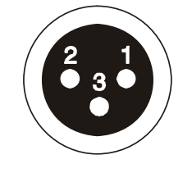


1 Earth 2 DMX- 3 DMX+

10CH for example
First（address 001） Second（address 011） Third（address021）
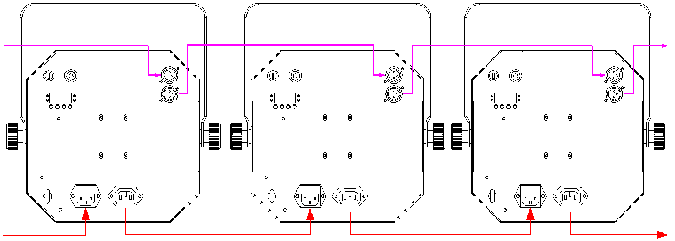

DMX in DMX out to next light

八、DMX address setting

Each fixture must set a specific starting address. When receiving signal transmission, fixture will receive channel control signals which from the starting address.

According to different requirements or easy to use, the user can set many value fixtures to the same address, also can set up a separate address for every device.

If you set the same address,all the devices will receive from DMX channels signal. All connecting fixtures are jointly controlled, controller can't separate control a device.

If you set a different address, each device will be separate from its particular set the starting address and begin accepting DMX512 control signal, so that more convenient separate control one device.

Using this method must be based on channel quantity of device to determine a starting address.
This light has 10 channels. When you use 10CH, you should set the starting address of the first unit to 1, the second unit to 11(10+1), the third unit to 21 (11+10), and so on.

九、Structure and material
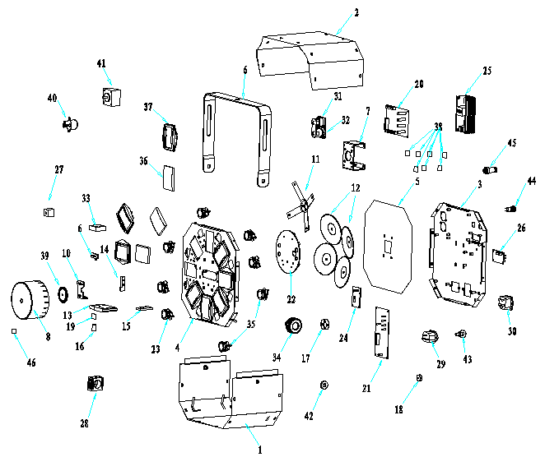


十、Installation
No. | Model No. | Name | quantity | Material No  物料编码
1 | SPL-RG-301-04 | Base plate | 1 | 311003111
2 | SPL-RG-301-05 | Top cover | 1 | 311006073
3 | SPL-RG-301-03 | Back plate | 1 | 311002074
4 | SPL-RG-301-02 | Front plate | 1 | 311001100
5 | SPL-RG-301-06 | Clapboard | 1 | 311020001
6 | SPL-RG-301-07 | Handle | 1 | 316001088
7 | SPL-RG-301-09 | Head cover | 1 | 311012014
8 | SPL-RG-301-08 | Motor stand 1 | 1 | 313001058
9 | SPL-RG-301-10 | Locating plate | 1 | 321001014
10 | SPL-RG-301-11 | Motor stand 2 | 1 | 313001059
11 | SPL-RG-301-12 | Reflection plate bracket | 1 | 313028001
12 | SPL-RG-301-13 | Reflection dish | 4 | 322013007
13 | SPL-RG-301-14 | FPC | 1 | 315001100
14 | SPL-RG-301-16 | Red laser plate | 1 | 313003010
15 | SPL-RG-301-15 | Green laser plate | 1 | 313003008
16 | SPL-RG-301-18 | Reverse bracket | 1 | 314001013
17 | SPL-RG-301-17 | Stand flange | 1 | 313001060
18 | SPL-RG-301-19 | Motor flange | 1 | 319001030
19 | 13*10*1.1mm | Pass red, reflect green | 1 | 302005003
20 | MB-29 | Main Board | 1 | 205001115
21 | MB-22A | LED Driver Board | 1 | 205002023
22 | ABL-54A | Aluminum base plate 1 | 1 | 205003102
23 | ABL-55A | Aluminum base plate 2 | 8 | 205003103
24 | LB-RG1 | Power | 1 | 203022001
25 | GZLU90-S 12V-7.5A | Switch power | 1 | 204001056
26 | AB-24A（with indicator light） | Display board | 1 | 205004019显示板
27 | Red Laser：100MW/650NM | SPL-R180B4 | 1 | 202109007
28 | Green Laser：50MW/532NM | SPL-G300H2 | 1 | 202008005
29 | male，250V,10A | Power socket | 1 | 301923008
30 | 250V/10A，with fuse | Power socket | 1 | 301923002
31 | IN，/K3F2C-B | Dmx in（male） | 1 | 301909007
32 | OUT,/J3F2C-B | DMX out（female）（female） | 1 | 301909008
33 | 3010，DC12V,0.08A | Fan | 1 | 301701025
34 | M8*12 | Handle screw | 2 | 306020003
35 | 25mm stand，45 degrees lens | LED lens parts | 8 | 302018003
36 | 60*39.5*9.5 | convex mirror | 8 | 302012028
37 | Plastic parts | convex lens holder | 8 | 303010012
38 | 14*14*1.2mm | Shivering glass | 80 | 302019026
39* | HYS8-12，￠40*2,￠3mm | 8 grating | 1 | 302001108
40 | 24BYJ48-36，DC12V | Step Motor | 1 | 301601012
41 | 39HB105C-12 | Step Motor | 1 | 301601004
42 | ￠20*￠8*3.0mm | Rubber mat | 2 | 303002004
43 | M6,Outer ring 20mm | Ring | 1 | 306019007
44 | ￠12 | Safety lock | 1 | 308010001
45 | M16,center 6mm，steel | Plug | 1 | 301935004
46 | meteor shower 020T，10*10*1.1mm | Grating filter | 1 | 302001104
1 Clamp
2 Handle

When install this equipment please make sure there's no flammable surfaces (decorated things, etc) within at least 2.5M and maintain minimum distance of 0.5M from the equipment to the walls.

Please make sure that there's no other equipment or decorating materials obstructed the exhaust fan and the vent-pipe.
Products should be install immobility.
In case of safety, it's very important that to connect the earth with line.
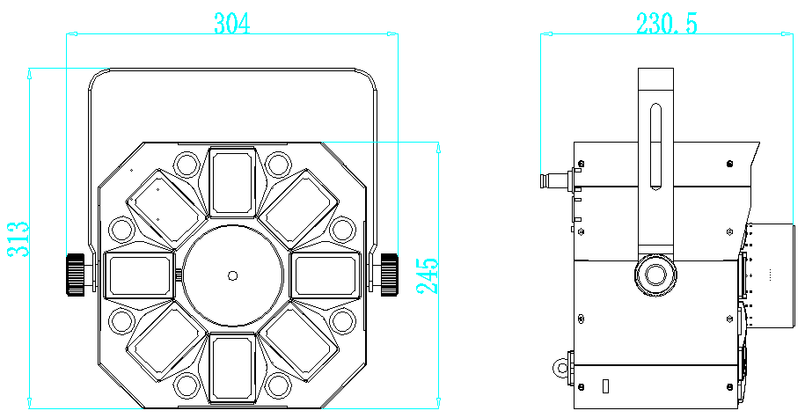
十一、Product size

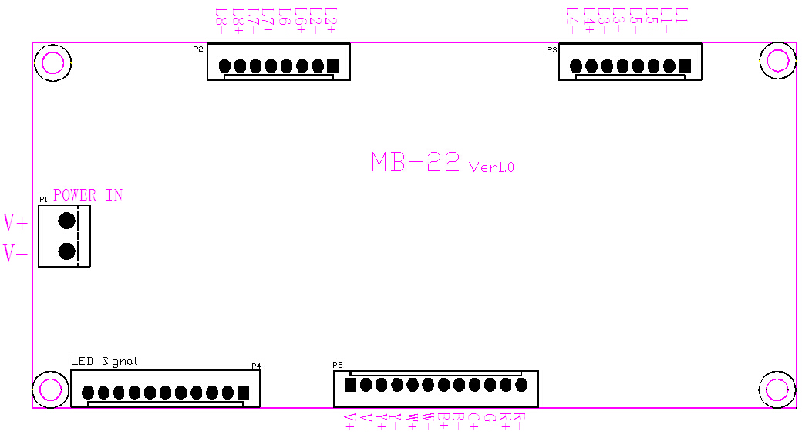
十二、Wiring diagram

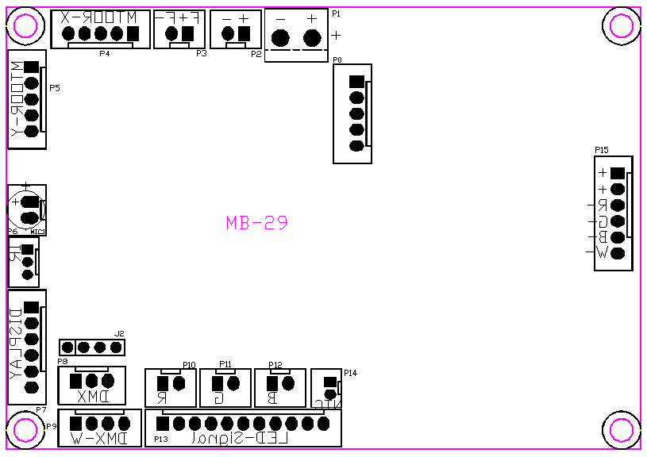

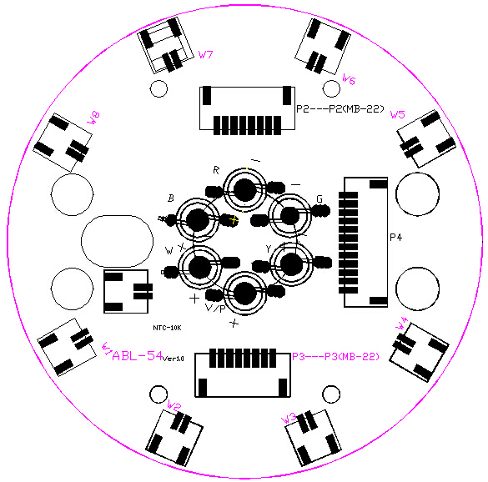

Declaration
Cleaning and maintenance

Cleaning should be performed every 15-day period, by using a sponge which is dipped with alcohol, rather than wet cloth or other chemical liquid, to clean the mirror.
Cut off power before cleaning and maintenance!
CAUTION

Attention

Do not see directly light source when open the light, and make sure power off before do any installation or maintenance.


 Wires connection must be professional person!
CAUTION

Warranty Card
This product is made of high-brightness transistor. We will provide 1 year warranty under the condition that user has operated the light normally and lifetime service. We won't provide warranty if the damage is caused by artificial or force majeure event. Cost of fittings should be charged by user if product need maintenance after 1 year .Please cut this warranty card and shipped it along with the product to our factory when applying for warranty.
Product： Purchasing date： Code of invoice：
Warranty date: From To
User’s name： Add：
Company： Tel：

